**Overview:**

The data analysis reveals significant insights into the income distribution among different age groups. A particular focus has been placed on identifying the age group that contributes the most to our revenue through product purchases.

**Key Finding:**

* **Dominant Age Group:** The 40 to 50 age range is identified as the age group with the highest income levels. This age bracket is not only financially stable but also shows a higher propensity to spend on our products compared to other age groups.

**Detailed Insights:**

* **Correlation between Sales and Income:**The Data reveals a strong positive correlation of 0.78 between sales and income. This indicates that as income levels increase, sales tend to rise proportionately. This relationship suggests that higher-income individuals are more likely to spend more on products, reinforcing the importance of targeting affluent demographics. Understanding this correlation helps in identifying potential high-spending customer segments, enabling more effective allocation of marketing resources and tailored product offerings to maximize revenue. With this data there is also an indicator for shirts having been a good majority of the sales in the highest predicted income ranges. Note: Formula used to derive the regression table. **A black symbols on a white background

  Description automatically generated**  
  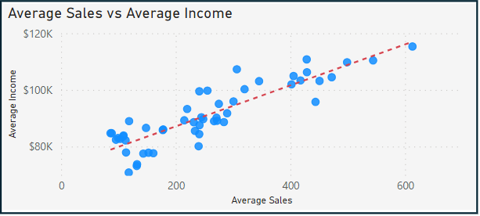A number with black text

  Description automatically generated
* **Correlation between Customer Ratings and Product Return Rate:**   
    
  A moderate negative correlation of 0.69 exists between customer ratings and product return rates. This means that higher customer satisfaction, as reflected in higher ratings, generally corresponds to lower product return rates. This insight emphasizes the critical role of maintaining high product quality and customer satisfaction to minimize returns and associated costs. By focusing on improving customer experiences and addressing feedback promptly, the company can reduce return rates and enhance overall profitability  
    
  A graph with blue dots and black lines

  Description automatically generatedA number with black text

  Description automatically generated
* **Customer Predicted to Have the Highest Income:**

Wilson Morgan is predicted to have the highest income amongst our customer base. Identifying high-income customers like Wilson Morgan is crucial for personalized marketing and customer retention strategies. High-income customers often have more disposable income, making them prime candidates for premium product offerings and exclusive deals. By understanding the purchasing behavior and preferences of such customers, the company can tailor its approaches to foster loyalty and increase lifetime value.  
  


* **Product to be Advertised the Most:**

The Chronograph Watch is identified as the product to be advertised the most due to its high customer ratings. High customer ratings reflect strong product approval and satisfaction, making the Chronograph Watch an ideal candidate for promotional campaigns. Leveraging positive reviews and high ratings in advertising can attract new customers and boost sales. By highlighting the features and benefits that garnered high ratings, the company can effectively market the Chronograph Watch to a broader audience.  
  
* **Linear Regression Formula to Predict Customer Income:**

The linear regression formula used to predict customer income involves dividing the sum of the total purchases made in the last six months and a constant (B value) by the slope (m value). This formula helps in estimating a customer’s income based on their purchasing behavior. By applying this predictive model, the company can segment customers according to their estimated income levels and customize marketing strategies accordingly. This approach enables more precise targeting and enhances the effectiveness of promotional efforts. Note: x = (b-y)/-m



**Conclusion:**

The 40 to 50 age range emerges as the primary income source for our products. Focusing on this demographic through targeted marketing, product development, and customer engagement strategies will likely drive continued revenue growth and strengthen our market position.